**DAILY ASSESSMENT FORMAT**

|  |  |  |  |
| --- | --- | --- | --- |
| **Date:** | **13-07-2020** | **Name:** | **Pragati M Kundalkar** |
| **Course:** | **Mathematics for Machine learning:linear algebra**  **Salesforce-built your admin career on salesforce**  **Revision of AMES** | **USN:** | **4AL17EC072** |
| **Topic:** |  | **Semester & Section:** | **6TH SEM**  **B - SEC** |

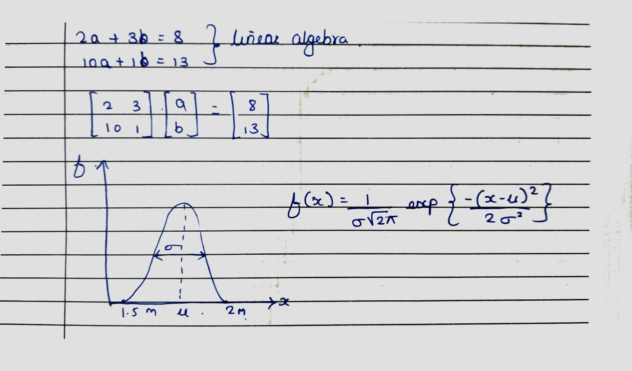Mathematics for Machine learning:linear algebra

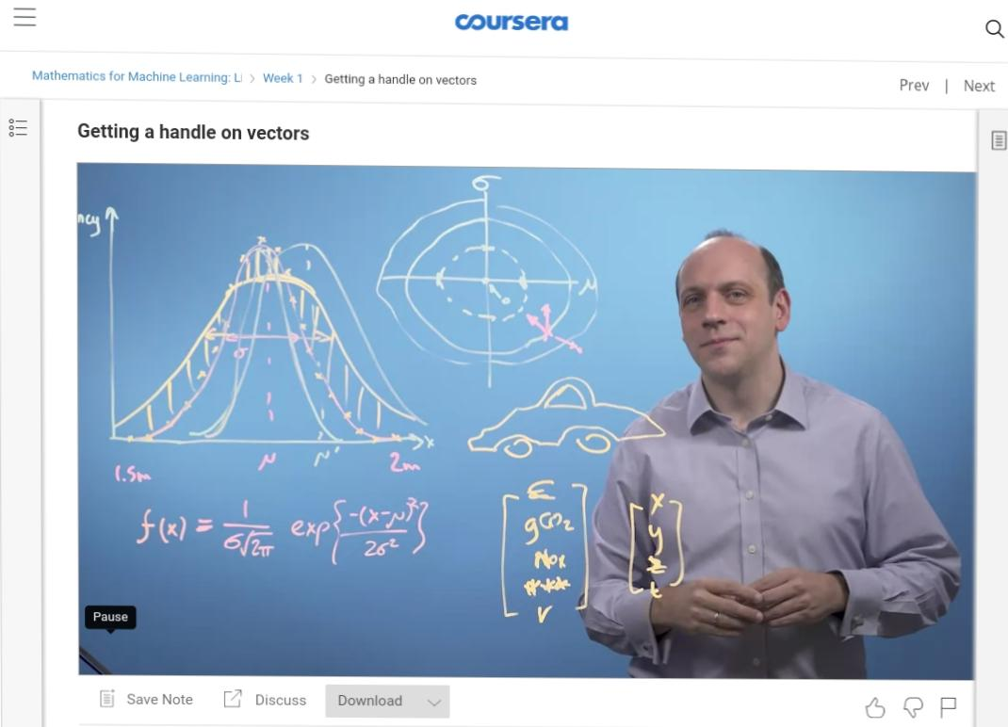

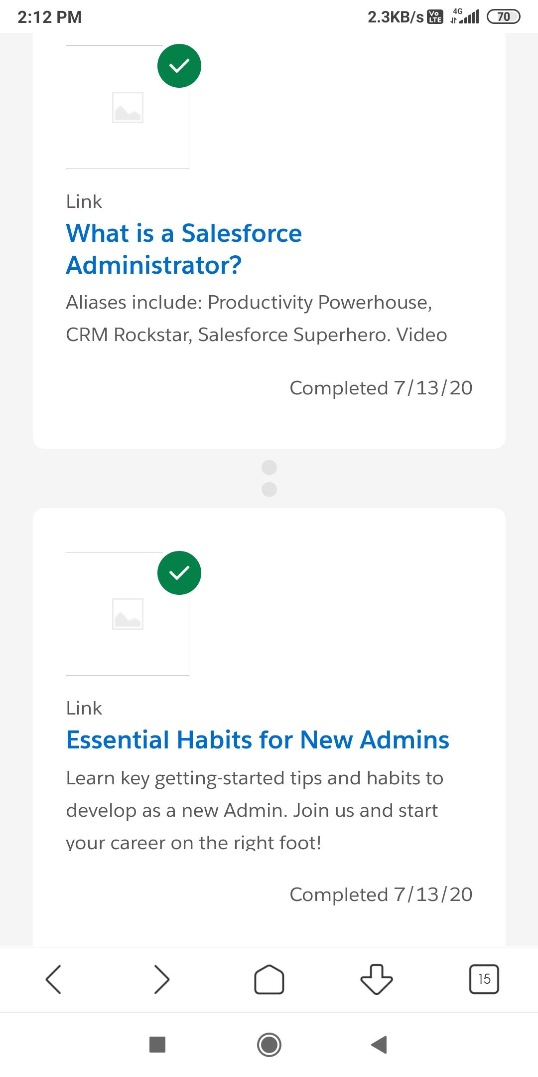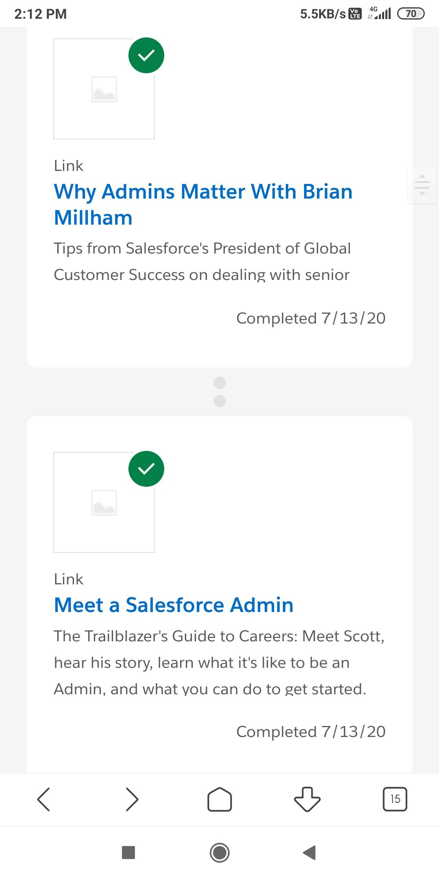Build your admin career on salesforce:

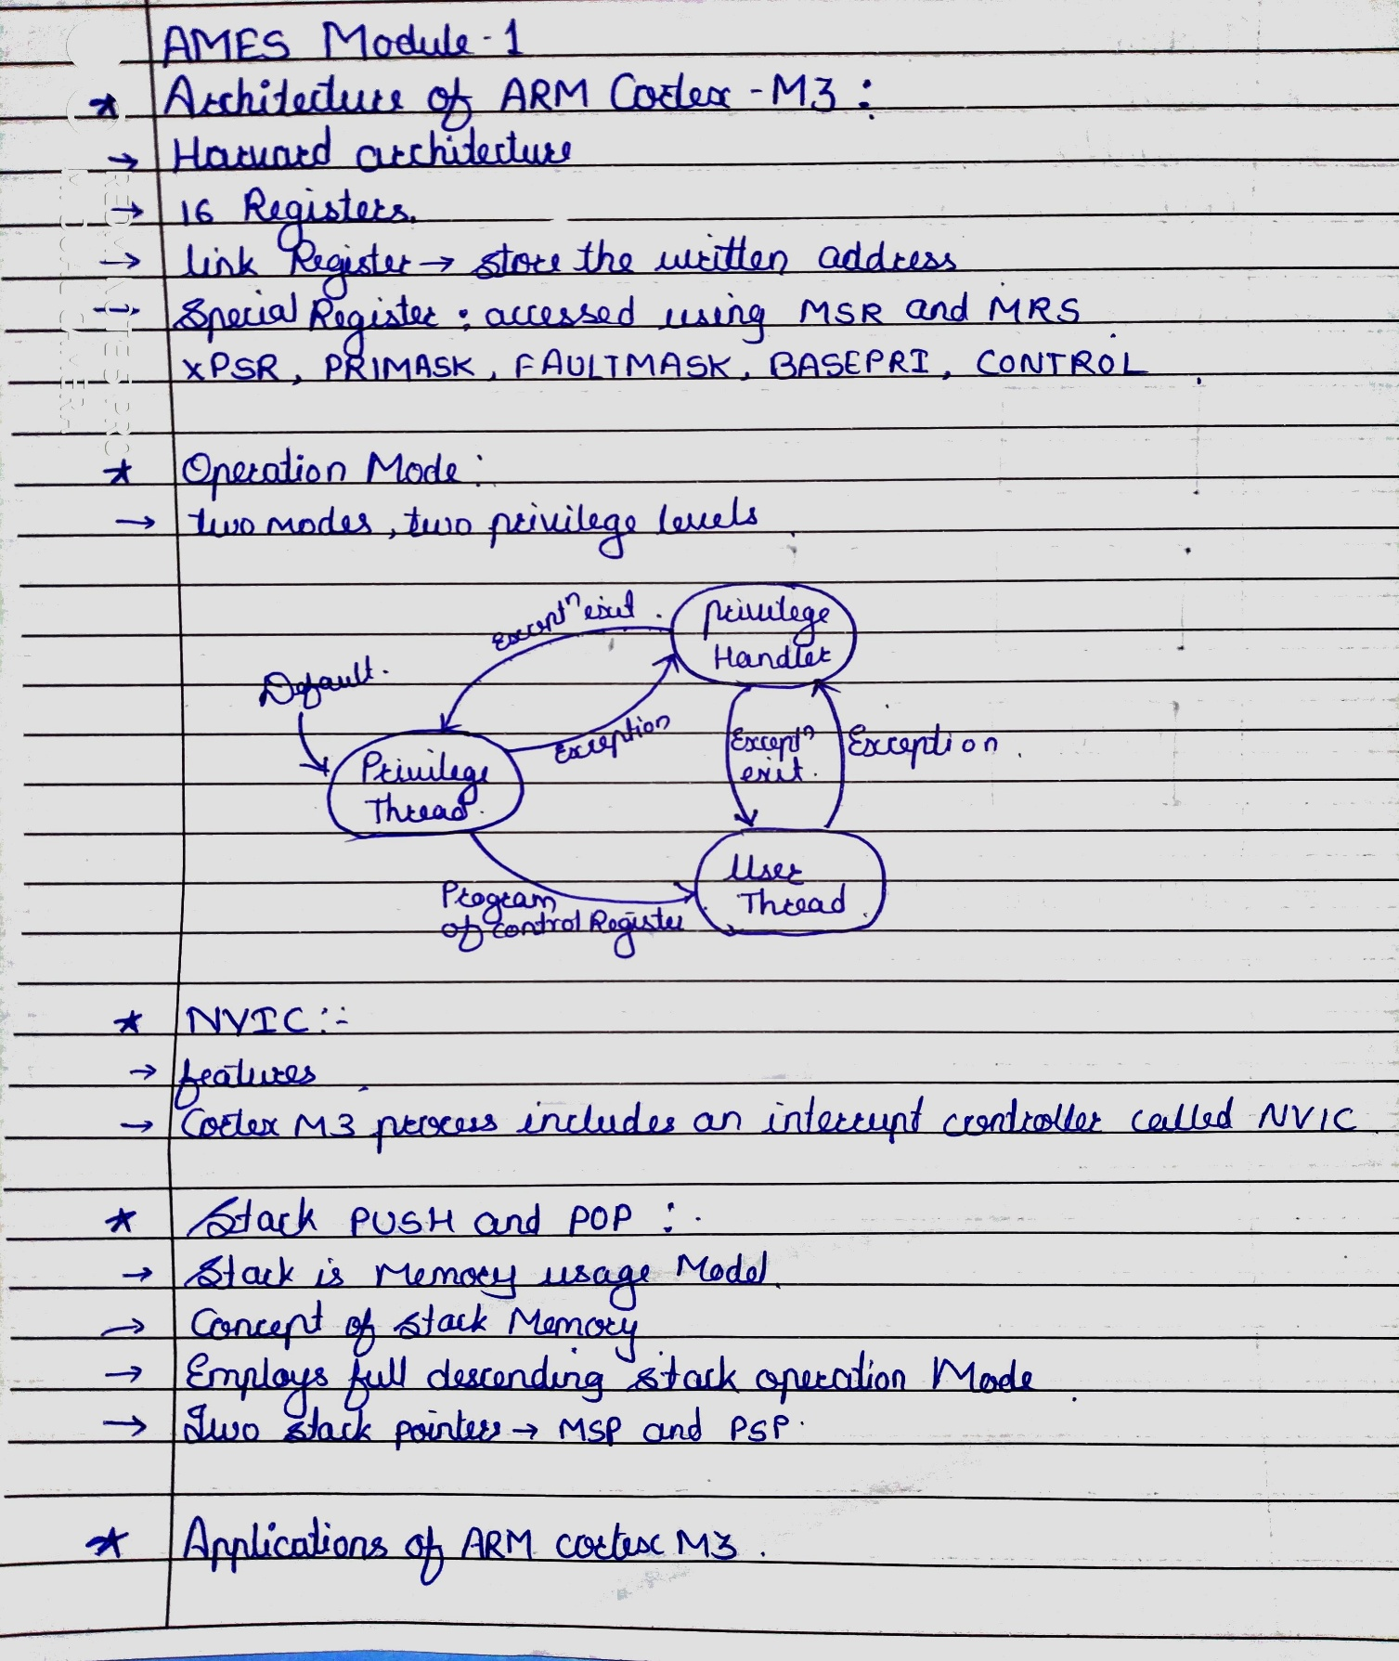Revision of AMES: